**NKOKONJERU PRIMARY SCHOOL – MBALE**

**END OF TERM II (INT) EXAMINATION – 2016 EXAMINER ONLY**

**P.2 SCIENCE Section A**

**Section B**

**TOTAL**

**EXAMINER**

**NAME: _________________________________________________STREAM: ______________**

1. Which sense organ do we use for seeing?

_____________________________________________________

1. Write two things got from domestic birds.
2. __________________________________________________
3. __________________________________________________
4. Name one animal that lives in water.

_____________________________________________________

1. Write one use of these things we make.

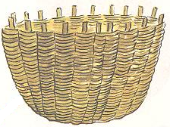

for ___________________________

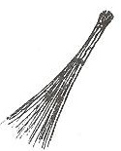

for ___________________________

1. Name any one useful insect.

_____________________________________________________

1. How do most birds move?

_____________________________________________________

1. ________________________ are things around us.

(Environment, sanitation)

1. Give two groups of living things.
2. __________________________________________________
3. __________________________________________________
4. 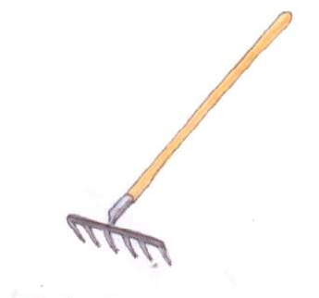Write one way of keeping our body clean.

_____________________________________________________

1. Name this material used to keep our places clean.

_____________________________________________________

1. Name the animal that gives us:
2. Mutton _________________________________________
3. Fillet __________________________________________
4. Pie __________________________________________
5. Mention two plants.
6. ___________________________________________________
7. ___________________________________________________
8. Read and draw.

|  |  |
| --- | --- |
|  |  |
| Charcoal stove | Pot |

1. Mention any three examples of non-living things.
2. ___________________________________________________
3. ___________________________________________________
4. ___________________________________________________
5. List down two things living things can do.
6. Living things ________________________________________
7. Living things ________________________________________
8. How can we keep our hands clean?

_____________________________________________________

1. Underline two materials we use to make balls.

Banana fibre, timber, polythen bags, clay

1. Which part of the body do we use for breathing?

_____________________________________________________

1. Which part of the body do we use to kick a ball?

_____________________________________________________

1. Fill in the missing letters correctly.
2. choler__
3. p__lio
4. 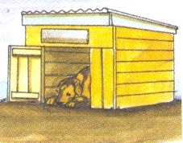Name the animal home below.

|  |
| --- |
|  |
|  |

1. Name one food which gives us energy.

_____________________________________________________

1. Name two common accidents in our community.
2. ___________________________________________________
3. ___________________________________________________
4. Mention two types of families.
5. ___________________________________________________
6. ___________________________________________________
7. ___________________ is the way of keeping places clean.

(Personal hygiene, Sanitation)

1. Draw and name one fruit.

SECTION B: (60 MARKS)

1. _________________ is the state of the atmosphere at the given time of the day.
2. Name two types of weather changes.
3. ___________________________________________________
4. ___________________________________________________
5. Match correctly:

Roots make food for the plant

Stem holds the plants firmly in the soil

Leaves transport water from the roots to other parts of the plant

1. Name these things which cause accidents in our community.

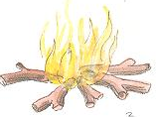____________________________

_______________________________

1. Mention two ways insects protect themselves.
2. ___________________________________________________
3. ___________________________________________________
4. Write two examples of harmful insects.
5. ___________________________________________________
6. ___________________________________________________
7. 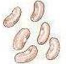Name these food stuffs.

_____________________________



_____________________________

1. Write down two things found in the First Aid box.
2. __________________________________________________
3. __________________________________________________
4. Underline two reasons why we should give First Aid

To save life

To jump

To reduce pain

To skip a rope.

1. List down three ways of keeping places clean.
2. __________________________________________________
3. __________________________________________________
4. __________________________________________________
5. 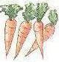Name these food crops.

_____________________________

1. How many legs has a hen?

_____________________________________________________

1. A young plant is called a (root, seedling, food)

_____________________________________________________

1. Write two uses of plants to people.
2. __________________________________________________
3. __________________________________________________

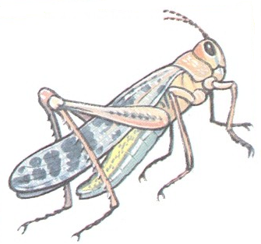

1. Name the parts of an insect below.

wings

abdomen

head

legs

thorax

**A**

**B C D**

A : _____________________________________________

B : _____________________________________________

C : _____________________________________________

D : _____________________________________________

End.